EXP NO:1

Convert color image into grayscale using OpenCV library.
Algorithm
- Import OpenCV and Matplotlib required Python libraries.
- Read input image from specified file location.
- Convert color image into grayscale using OpenCV.
- Display original image using Matplotlib visualization function.
- Display grayscale image using gray color map.
- Verify successful grayscale conversion by comparing outputs.
Program:
import cv2
import matplotlib.pyplot as plt
img = cv2.imread("/content/Picture1.jpg")
gray = cv2.cvtColor(img, cv2.COLOR_BGR2GRAY)

plt.imshow(cv2.cvtColor(img, cv2.COLOR_BGR2RGB))
plt.title("Original Image")
plt.axis("off")
plt.show()

plt.imshow(gray, cmap="gray")
plt.title("Grayscale Image")
plt.axis("off")
plt.show()

Output:
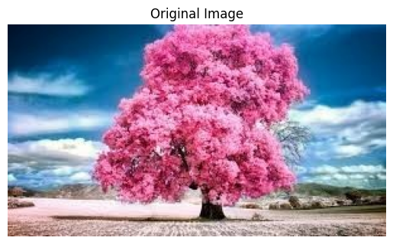
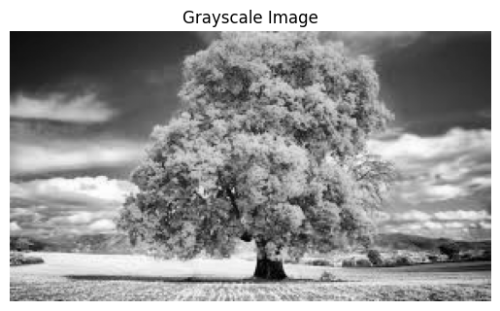
Result: The input color image was successfully converted into a grayscale image and both the original and grayscale images were displayed successfully.

